SELECT Macroeconomic Indicators

The following key economic statistics: GDP, Employment, Inflation, Consumer Sentiment, and Budget Deficit are some of the economic indicators used to describe the state of the economy. Primary sources for information include: the OECD Key Economic Indicators (KEI) database; In addition, the Federal Reserve Bank of New York publishes an Economic Indicators Calendar and the Bureau of Labor Statistics publishes Economic News Releases.

Gross Domestic Product (GDP) – Represents the size of the economy, it is the total market value of all the goods and services produced within the borders of a nation during a specified period. The growth in GDP is one of the primary indicators used to gauge the health of a country's economy.

Table 1: GDP Top 10 Countries 2011 - 2012
  Ranking | Economy | (millions of US dollars) 2012
  1 | United States | 15,684,800
  2 | China | 8,227,103
  3 | Japan | 5,959,718
  4 | Germany | 3,399,589
  5 | France | 2,612,878
  6 | United Kingdom | 2,435,174
  7 | Brazil | 2,252,664
  8 | Russia | 2,014,775
  9 | Italy | 2,013,263
  10 | India | 1,841,717
  Ranking | Economy | (millions of US dollars) 2011
  1 | United States | 14,991,300
  2 | China | 7,321,935
  3 | Japan | 5,896,794
  4 | Germany | 3,600,833
  5 | France | 2,779,719
  6 | Brazil | 2,476,652
  7 | United Kingdom | 2,444,883
  8 | Italy | 2,192,357
  9 | Russia | 1,899,085
  10 | India | 1,872,845
Source: World Bank http://databank.worldbank.org/data/download/GDP.pdf

GDP can be calculated in one of two ways: by the income approach GDP(I) adding up total compensation to employees, gross profits for all firms (both incorporated and non-incorporated), and taxes (minus subsidies) or by the expenditure method adding up total consumption, investment, government spending and net exports C+I+G+(X-M), both measures should arrive at roughly the same total.

Release Date: | Advance release: four weeks after quarter ends;  Final release: three months after quarter ends
Coverage: | Previous quarter
Released By: | Bureau of Economic Analysis (BEA)
Latest Release: | http://www.bea.doc.gov/bea/dn1.htm
Source: Investopedia “Economic Indicators: Gross Domestic Product (GDP)”

Unemployment Rate - The percentage of the total labor force that is unemployed but actively seeking employment and willing to work. It is calculated by dividing the unemployed and actively seeking work by the total labor force.

Table 2: U.S. Unemployment Rate Jan 2003 – Aug 2013
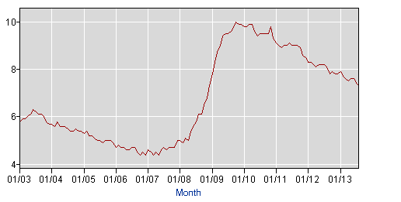
Source: Bureau of Labor Statistics http://data.bls.gov/timeseries/LNS14000000

The Bureau of Labor Statistics (BLS) calculates the U.S. unemployment rate from monthly data provided by the Current Population Survey. This survey is conducted for the BLS by the U.S. Bureau of the Census and covers 60,000 members of the civilian, noninstitutional population aged 16 years or older.

Release Date: | Early each month
Coverage: | Previous month
Released By: | Bureau of Labor Statistics (BLS)
Latest Release: | http://www.bls.gov/cps/cps_htgm.htm
Source: http://www.bls.gov/cps/cps_htgm.htm

There are four types of unemployment:
- Frictional: natural adjustments that occur in an economy (e.g., people changing jobs)
- Structural: mismatch between job skills needed and the job skills of the unemployed
- Seasonal: predictable changes in yearly unemployment conditions, caused by factors such as weather conditions, harvest cycles, vacations, and holidays
- Cyclical: slowing or negative growth in a business cycle
Inflation – Measures the rate at which the general level of prices for goods and services is rising, and subsequently, purchasing power is falling. Central banks attempt to stop severe inflation, along with severe deflation, in an attempt to keep the excessive growth of prices to a minimum.

Table 3: U.S. Inflation Rate 2003 - 2013
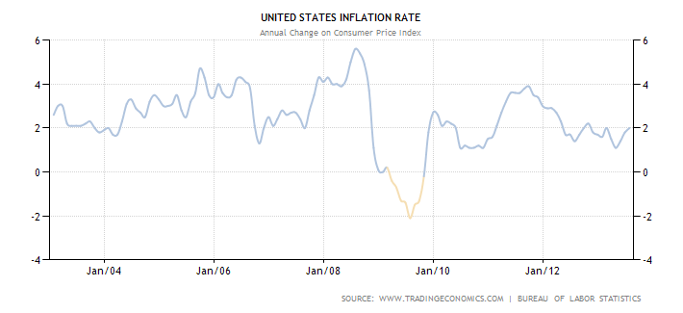
Source: http://www.tradingeconomics.com/united-states/inflation-cpi

Rates of inflation are calculated using the Current Consumer Price Index published monthly by the Bureau of Labor Statistics (BLS). This data represents changes in prices of all goods and services purchased for consumption by urban households.

Release Date: | Each month and yearly on September
Coverage: | Previous 12 months ending August
Released By: | Bureau of Labor Statistics (BLS)
Latest Release: | http://www.bls.gov/bls/inflation.htm

Consumer Sentiment – A statistical measurement and economic indicator of the overall health of the economy as determined by consumer opinion. Consumer sentiment takes into account an individual's feelings toward his or her own current financial health, the health of the economy in the short term and the prospects for longer term economic growth.

Consumer sentiment developed as an economic statistic during the mid-20th century, and has become a barometer whose results influence public policy, economic policy and the stock markets. When consumer sentiment is less positive, markets typically react bearishly and vice versa.

One of the closely followed publications of the consumer sentiment is the University of Michigan Consumer Sentiment Index (MCSI).

Table 4: Michigan Consumer Sentiment Index (MCSI)
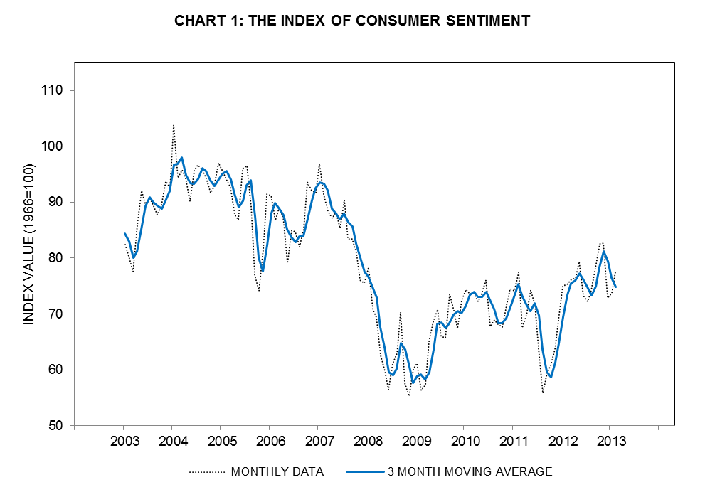
Source: http://www.sca.isr.umich.edu/charts.php

Consumer confidence is an economic indicator which measures the degree of optimism that consumers feel about the overall state of the economy and their personal financial situation. How confident people feel about stability of their incomes affect their economic decisions, such as spending activity, and therefore serves as one of the key indicators for the overall shape of the economy. In essence, if consumer confidence is high, consumers will be making more purchases. On the other hand, if confidence is lower, consumers tend to save more and spend less.

Release Date: | Monthly
Coverage: | Previous month
Released By: | Thomson Reuters/University of Michigan
Latest Release: | http://www.sca.isr.umich.edu/charts.php

Budget Deficit - Deficit essentially refers to the difference between cash inflows and outflows. Deficit is the opposite of "surplus" and is synonymous with shortfall or loss.

Table 5: US Budget Deficit from 2003 to 2012 (in Billion Dollars)

Source: https://www.cbo.gov/publication/44507

The U.S. government’s fiscal year runs from October to September. The deficit has been falling due mostly to increased tax revenues. Receipts of individual income taxes, payroll taxes and corporate taxes have collectively grown 13 percent from a year earlier, reflecting both higher tax rates and an improving economy. In addition, government spending is down 4 percent partly due to the automatic budget cuts known as “the sequester.”

Release Date: | Monthly
Coverage: | Previous month
Released By: | Bureau of the United States Department of Treasury
Latest Release: | http://www.fms.treas.gov/mts/index.html

Graduate Assistant Kaoutar Houmairy and Research Assistant Shivani Janani, Babson College contributed to the completion of this class note.

stats.oecd.org/mei/default.asp?rev=4
http://newyorkfed.org/research/calendars/nationalecon_cal.html
http://www.bls.gov/bls/newsrels.htm
According to the International Labor Organization’s standards, individuals are unemployed if they are (1) without a job, (2) available to work (e.g., not in a hospital, asylum, or prison), and (3) actively seeking employment.
Managing in a Global Economy, Chapter 3, p. 84
Managing in a Global Economy, Chapter 3, p. 83
Managing in a Global Economy, Chapter 3, p. 93
http://www.investopedia.com/terms/i/inflation.asp
http://www.usinflationcalculator.com/inflation/current-inflation-rates/
http://www.investopedia.com/terms/c/consumer-sentiment.asp
http://www.statisticbrain.com/global-consumer-confidence/
http://www.investopedia.com/terms/d/deficit.asp
http://www.marketwatch.com/story/us-budget-deficit-down-35-through-august-2013-09-12

